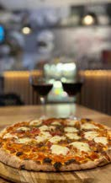

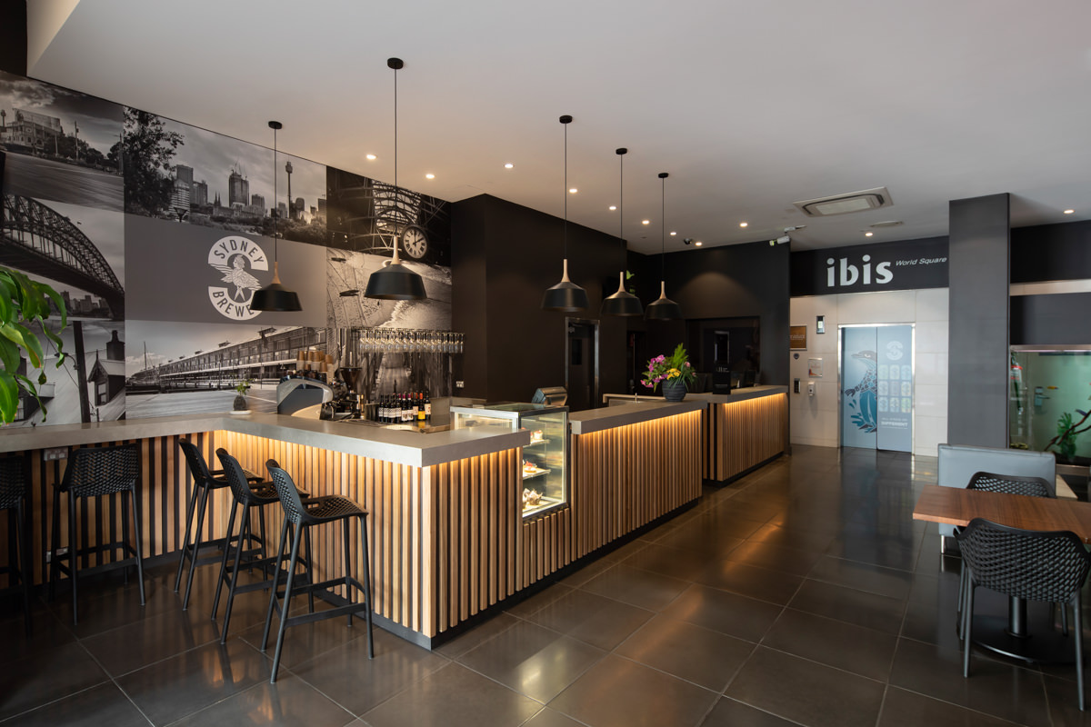

# Ibis Sydney World Square

Ibis Sydney World Square is located in the heart of Sydney CBD and minutes from the historic Queen Victoria Building, Chinatown and Darling Harbour, and a 10 minute walk to UTS. The hotel has secure key entry to all accommodation floors, a 24 hour reception desk and security services.

# ACCOMMODATION ROOMS

Ibis World Square has a variety of double and twin rooms available, the rooms are light and airy and all come with a study area with lamp, chair and desk. Weekly housekeeping service.

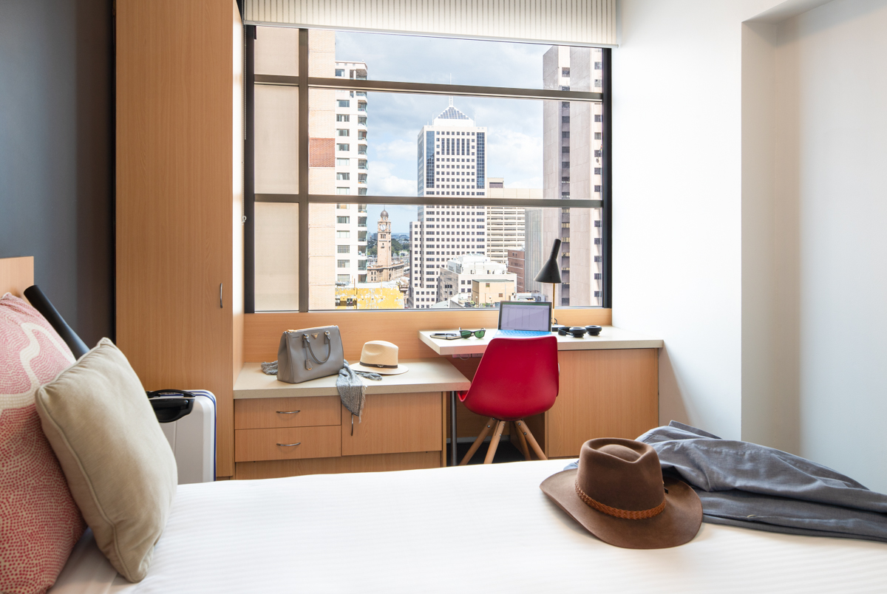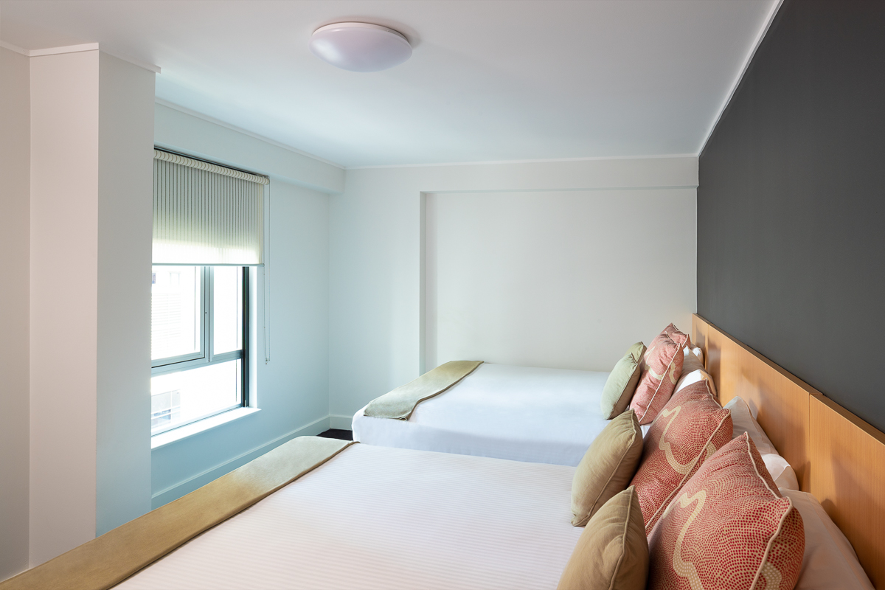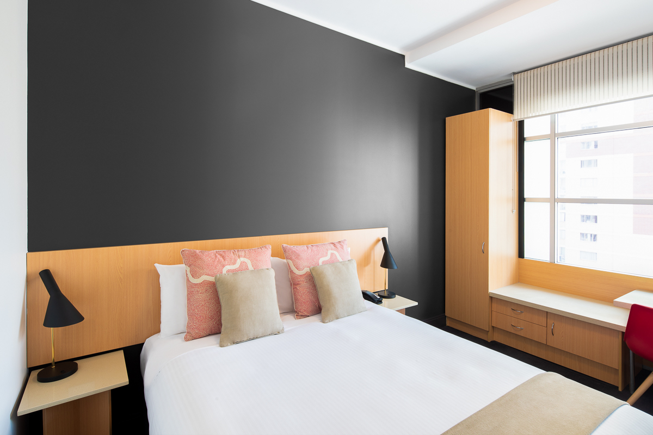

# BOOKINGS

We are able to offer 10% discount from the best available rate for a queen standard or twin room (twin is 2 x beds). Breakfast can be added at a further $15 per day, alternatively there is a Grab ‘n Go café in the lobby. Wi-Fi will be included in the rate if the guest is a member Accor Live Limitless program (joining is free). Please call or email the hotel and quote the preferential code **2602AMRCSI** to access the rate, one of our team will be in contact for your credit card details.

|  |  |
| --- | --- |
| **BOOKINGS CAN BE MADE VIA IBIS WORLD SQUARE RESERVATIONS +61 29217 6797 OR EMAIL** [**H2132@ACCOR.COM**](mailto:H2132@ACCOR.COM) | |
| **First Name** |  |
| **Surname** |  |
| **Number of Guests** |  |
| **Email Address** |  |
| **Phone Number** |  |
| **Room Type – Queen or Twin – please indicate** |  |
| **Do you require breakfast at $15 per person** |  |
| **Arrival Date** |  |
| **Departure Date** |  |
| **Credit Card with Expiry date (LAST 4 DIGITS ONLY)** |  |
| **Preferential code is Block Code 2602AMRCSI** |  |

Bookings are open until 17.02.26 and are limited in availability.



Ibis World Square - 382 Pitt Street, Sydney, 2000