Full title

Antonella Sola^{1*}, Author Two¹, Dante Alighieri²
¹Manufacturing Business Unit, Commonwealth Scientific and Industrial Research Organisation (CSIRO), Clayton, 3169 VIC, Australia
²Department of Literature “Divina Commedia”, University of Florence, 50100 Florence, Italy

* Corresponding author. Email antonella.sola@csiro.au

Max. length for the main text is 200 words. Font is Times New Roman, 12 points, 1.15 spacing, justified. The abstract, including max. one optional image and bibliography, should not exceed one page. English is the official language for the symposium [1]. Authors are required to submit their abstract as an editable file (preferably in .doc or .rtf format) by mail to Antonella Sola. Midway upon the journey of our life I found myself within a forest dark, for the straightforward pathway had been lost. Ah me! How hard a thing it is to say what was this forest savage, rough, and stern, which in the very thought renews the fear. So bitter is it, death is little more; but of the good to treat, which there I found, speak will I of the other things I saw there. I cannot well repeat how there I entered, so full was I of slumber at the moment in which I had abandoned the true way [2].

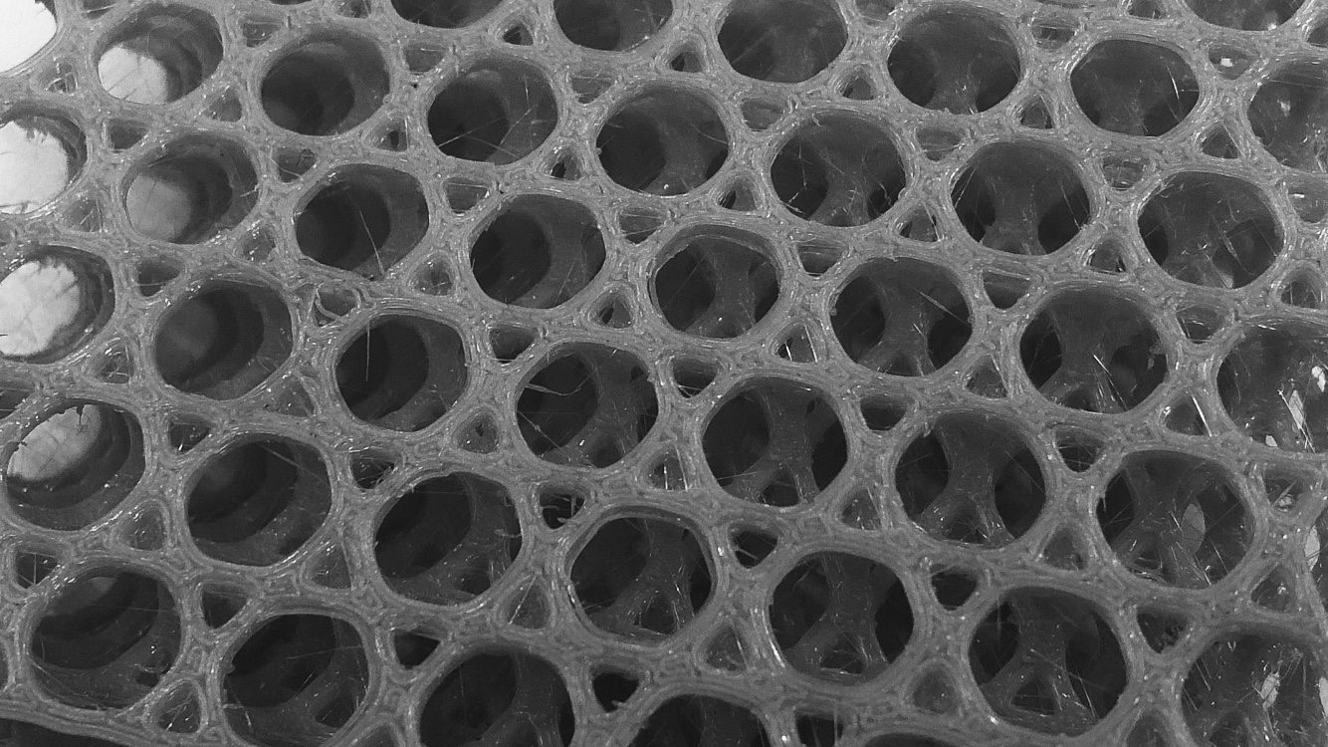
Figure 1. Polymer-based lattice 3D printed by fused filament fabrication in CSIRO’s Fused filament fabrication facility (4F). Size of the cells: 5mm. (Caption style: Times New Roman, Italic, 9 points)

Bibliography
- D. van der Geer, J.A.J. Hanraads, R.A. Lupton, The art of writing a scientific article, J. Sci. Commun. 163 (2010) 51–59. https://doi.org/10.1016/j.Sc.2010.00372.
- D. Alighieri, La Divina Commedia, first ed., Numeister&Mei, Foligno, 1472.

